|  |
| --- |
| Krein game division |
| POLICE CAR THIEF |
| **Win if you can** |
| Version #1    All work Copyright © 2016 by Krein Game Division.  All rights reserved. |
| **Douglas Krein** |

**Table of Contents**

**Contents**

I. Game Overview 3

II. GitHub commits 3

III. Table of contents 3

IV. Game Play Mechanics 4

V. Controls 4

VI. Mockup screen 4

VII. Screen descriptions 4

VIII. Avatar 7

IX. Enemy 7

X. Scoring 8

# Game **Overview**

In this game you have to make points collecting fuel cans and avoid crash with other cars.

# GitHub commits

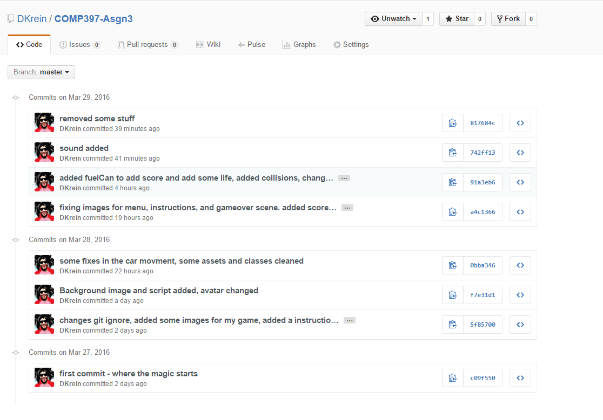

# Table of contents

|  |  |  |
| --- | --- | --- |
|  | Type | Name |
| 1 | Image | avatar.png |
| 2 | Image | BackButton.png |
| 3 | Image | BlackBackground.png |
| 4 | Image | enemy1.png |
| 5 | Image | Enemy2.png |
| 6 | Image | Enemy3.png |
| 7 | Image | Enemy4.png |
| 8 | Image | fuelCan.png |
| 9 | Image | gameOverBg.png |
| 10 | Image | instructionsBg.png |
| 11 | Image | InstructionsButton.png |
| 12 | Image | menuBg.png |
| 13 | Image | NextButton.png |
| 14 | Image | RestartButton.png |
| 15 | Image | road.png |
| 16 | Image | StartButton.png |
| 17 | Image | WhiteBackground.png |
| 18 | Sound | bgTheme.mp3 |

# Game **Play Mechanics**

The player have to avoid the cars to don’t get damage and pick up the fuel cans to score or repair the car.

# Controls

Move your mouse to control the car.

# Mockup screen

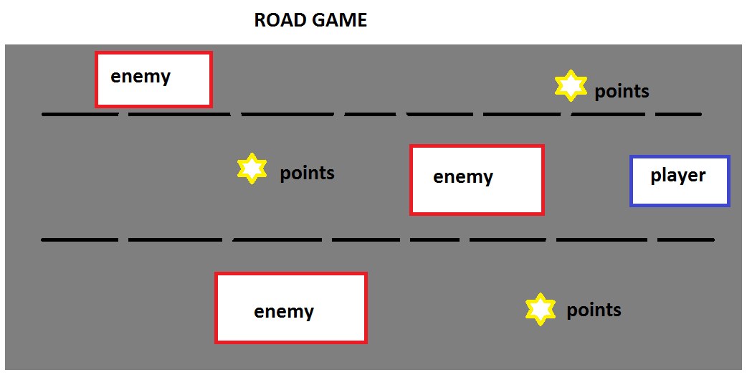

# Screen descriptions

MENU:

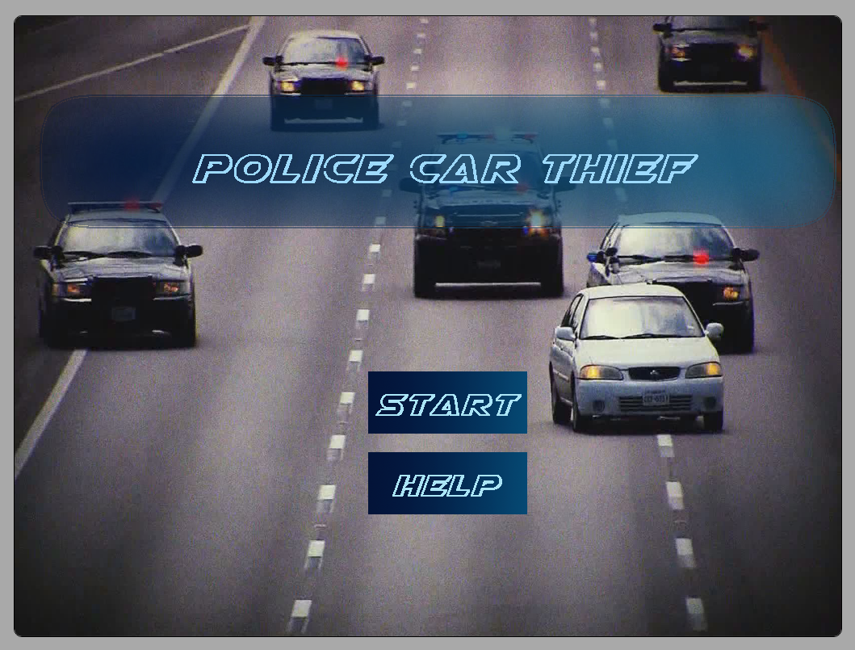

INSTRUCTION:

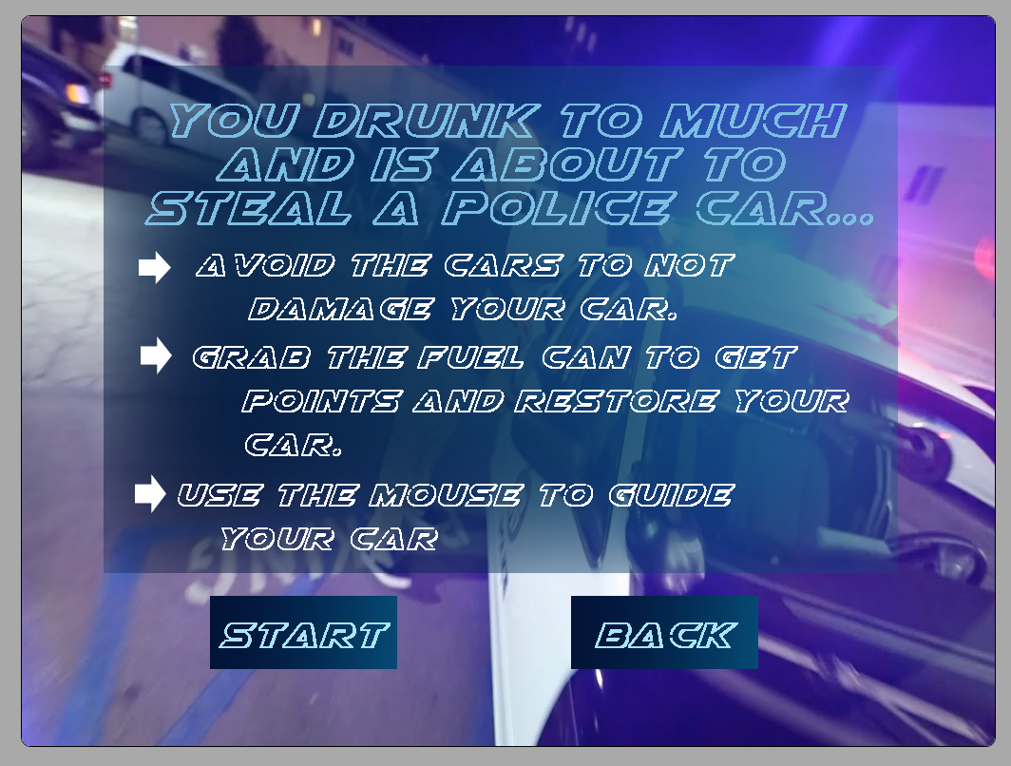

PLAY:

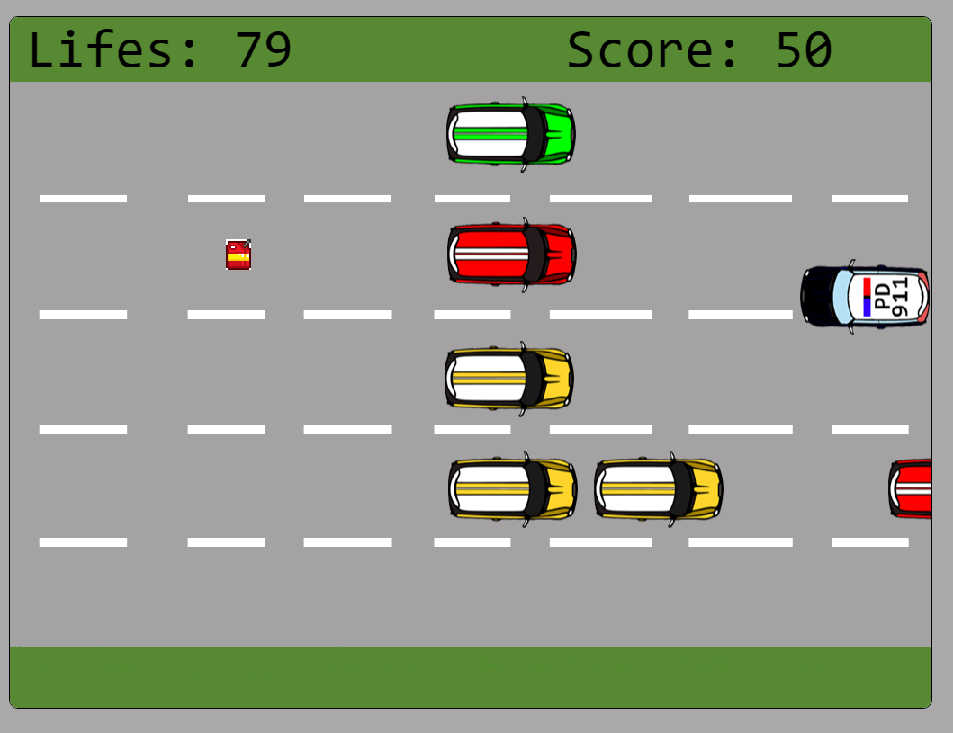

GAMEOVER:

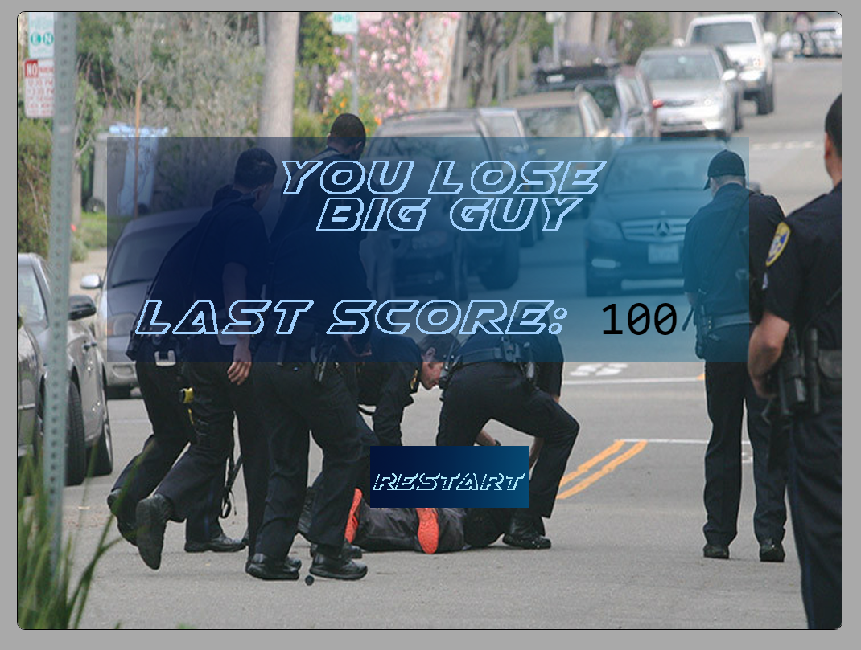

# Avatar

|  |  |
| --- | --- |
| Title | Sprite |
| Player |  |

# Enemy

|  |  |
| --- | --- |
| Title | Sprite |
| Enemy1 |  |
| Enemy2 |  |
| Enemy3 |  |
| Enemy4 |  |
|  |  |

# Scoring

|  |  |
| --- | --- |
| Title | Sprite |
| Fuel Can |  |